SENIOR CHEMISTRY OLYMPIAD QUESTIONS 2012 RAW DATA
RATE OF CHEMICAL REACTIONS
- A chemist has been studying a reaction involving two reactants X and Y. She timed the reaction for different concentration of the reactants and records the data in this table. She wrote the rate law for reaction in the form. R = K [x]ª[y]^{b}
Trial | X(M) | Y(M) | Reaction rate(M/min)
1 | 0.01 | 0.04 | 0.02
2 | 0.02 | 0.04 | 0.08
3 | 0.03 | 0.04 | 0.18
4 | 0.04 | 0.01 | 0.04
5 | 0.04 | 0.02 | 0.08
6 | 0.04 | 0.03 | 0.12

- Write down the values of a, b and K. [4, 4, 4]
- Write the overall order of the reaction [3]

ACIDS AND BASES
- The table below shows a list of pH range for common substances. You can choose one, more or none at all.
S/N | Substances | pH
1 | Grape fruit juice | 3.0 to 3.5
2 | Milk | 6.4 to 6.6
3 | Rain water | 5.5 to 5.8
4 | Soda | 2.5 to 4.0
5 | Stomach acid | 1.0 to 3.0
6 | Vinegar | 2.5 to 3.5

Which substance could have?
- Hydrogen ion concentration equal to about 1.0 x 10 ⁻⁴M
- Hydroxide ions of about 2.5 x 10 ⁻⁸M
- 1.0 x 10⁻¹³M hydroxide ion.
- What should be the concentration of hydrogen and hydroxide ions in a substance whose pH value falls mid way of the entire pH scale? [2 , 3, 2, 3]
- A new fertilizer is made by mixing Calcium Phosphate and its conjugate acidic salt Calcium Hydrogen phosphate.
- State one common name given to such a mixture of salts or solutions of salts. [1]
- State the advantage of using a fertilizer whose composition is made up of such mixture of salts apart from making soil fertile. [1]
- From the list below, choose one which befits the description in sentence that fellow. You may pick it once, more than once or not at all.
Arrhenius acid
Brфnsted – Lowry base
Lewis Acid
Arrhenius base
Brфnsted – Lowry Acid
- A substance which accepts hydrogen – ion
- Describes a substance that yields hydroxide ions in aqueous solution.
- Describe a substance that can accept a pair of electrons to form a covalent bond. [1, 1, 1]

ORGANIC CHEMISTRY
- Dimethyl ether CH₃OCH₃ and Ethanol CH₃CH₂OH are some of the old organic solvents. The structure of two compounds are written below.
DIAGRAM A DIAGRAM B
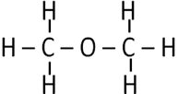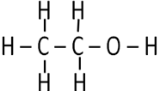
- What are the two compounds called? [1]
- In a 2011 J.E.T.S a girl scientist claimed that the structure of Ethanol should not be as in diagram B above instead she proposed hers below in diagram C

DIAGRAM C

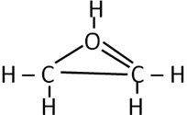
- Identify and state two things incorrect about her proposed structure. [1]
- By way of drawing an alternative structure, what modifications should be made for her proposed structure she made to make the formula acceptable though not for ethanol? (Writing a copy of diagrams A and B gains no mark) [3]
- In Kekule’s structures he proposed rings as part of the structures. Which consequently made Cyclohexane (C₆H₁₂) and Hexene (C₆H₁₂) to like a pair of Dimethyl ether and ethanol.
DIAGRAM D DIAGRAM E
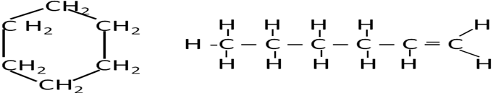
Cyclohexane Hexene
- State two distinctive differences between the compounds in Cyclohexane IN Diagram D and Hexene Diagram E. [2]
- What is likely general formula of an homologous series that contains Cyclohexane? [2]
- State at least three similarities between Cyclohexane in diagram D and Hexene in diagram E. [3]
- Octane rings are mixed to normal straight chains in order to increase caloric value of petrol and reduce cracking effect.
- State one thing that was done to petrol to reduce the knocking effects on engines. [1]
- State one new thing done to petrol to avoid the anti knocking agent effects on the environment. [2]

ENTHALPY AND ENERGY
- Ethanol (C₂H₅OH) is a most important industrial chemical and is used as a solvent and intermediate in large scale organic synthesis. Ethanol is commercially prepared by the reaction of Ethene and Steam in presence of nickel catalyst. The reaction equation is as below.
C₂H_{4 (g)} + H₂O_{(g)} C₂H₅OH_{(g)}
The standard enthalpy of the reaction can be determined by using the standard changes of combustion at 298K
/KJmol⁻¹
C₂H₄ _{(g)} -1411
C₂H₅OH _{(g)} -1367
- Calculate the enthalpy change for the following reaction. [2]
C₂H_{4 (g)} + H₂O_{(l)} C₂H₅OH_{(l)}
- (i) Define the term standard enthalpy change of combustion. [1]
(ii) State why the state symbols quoted in industrial process have been changed in given reaction in (a). [1]
(iii) Write the complete combustion of ethanol in plentiful of air.(include state symbols) [3]
- (i) Sketch the energy diagram profile for the formation ethanol from ethene based on energy of combustion data.( Assume same energy is used in formation as in combustion) .[3]
(ii) Is the reaction endothermic, exothermic or none ? [1]

ATOMS AND IONISATION ENERGY
- Sir James Jeans, who was a great populariser of science once described an atom of carbon as being like six bees buzzing around a space of the size of a football stadium.
- (i) Suggest what were represented by the six bees in this description. [1]
(ii) Explain (in terms of an atom of carbon) what stopped the from flying away from the football stadium [1]
(iii) What is missing from Jean’s description when applied to an atom of carbon? [1]
- (i) The diagram below represents energy levels of the orbital in an atom of the second period lithium to neon.
Copy and complete energy levels to indicate the principal quantum number and the type of orbitals at each energy level at each energy level.
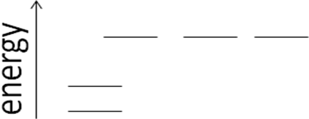
Nucleus [2]
(ii) Sketch the shapes of the two different orbitals. [2]
(iii) Copy and complete the electron configurations of nitrogen and oxygen on the energy level diagrams partially shown for you below.
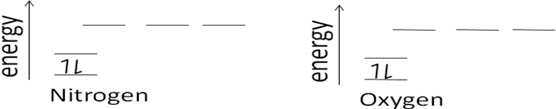 [4]
(iv) Write the formulae of negatively charged ions formed by these elements in a simple binary compounds. (Nitrides and oxides) [1,1]
(v) Why do nitrogen and oxygen form negative ions, but not positive ions in simple binary simple compounds. [2]

REACTIONS PERCENTAGE YIELD AND BALANCED EQUATIONS
- Dr. Chisha of the University of Zambia Chemistry department discovered that Pentyl acetate has actually a banana flavor when he was making Maheu for trade kings. The empirical formula for Pentyl acetate was C₇H₁₄O₂. It was further noted that the approximate molar mass was 130g/mol.
- Work out the correct molecular formula for Pentyl acetate. [2]
- In order for Pentyl Acetate a banana flavor to be made Pentan-1-ol C₅H₁₂O and Acetic acid C₂H₄O₂ were mixed.
C₅H₁₂O_{(l)} + C₂H₄O_{2(aq)} C₇H₁₄O_{2(aq)} +H₂O_{(l)}
If 860Kg of Ethanol is mixed with 860Kg of acetic acid. Determine.
- The excess reagent
- The limiting reagent
- If 1020Kg of Pentyl Acetate was produced, work out the percentage yield. [2, 2, 3]
- Work out how much of the excess reagent remained after the reaction. [3]
- (i) To which homologous series of compounds does the Pentyl Acetate compound belong to? [1]
(ii) A J.E.T.S boy in 2011 fair too claimed he had as well managed to form an apple flavor and that he used 2-Methyl pentan -2-ol and acetic acid. Draw the product of an apple flavor from these reactants [2]

METALS AND EXTRACTION OF METALS.
7. Aluminum is third most abundant elements in the Earth’s crust occurring in minerals.
(a) Name the mineral from which Aluminum is extracted. [1]
(b) (i) Describe with the help of diagram the electrolytic extraction of Aluminum from purified Aluminum Oxide. State what material are the electrode made of? [4]
(ii) Give an ion-electron equation for the process at anode and cathode.[2]
(iii) What further reaction takes place at the anode? Describe and write
chemical equation [2]
(c) Much of the body work of trains, air crafts and ships are made from Aluminum rather than steel. State two advantages of using aluminum in making vehicles. [2
(d) An alloy used in making bicycle frames is suspected to be from hard steel and titanium. It is light and very strong. A J.E.T.S student was required to determine the percentage composition of the alloy in frame.
She first dissolved the alloy in dilute hydrochloric acid where a green solution was obtained. The solution was then titrated with permanganate solution till a brown solution was formed.
- Assuming titanium forms a colourless solution with acids, write the chemical equation involving the observed colour changes in ionic form[2]
- What do we call the type of reaction exhibited by one metal in an alloy?[2
- Give a reason that supports your answer in d(ii) above. [1]
______________________________________________________________________________
PERIODIC TABLE AND IONISATION ENERGY
8. The periodic table currently used is derived directly from that proposed by Mendeleev in 1869 after he had noticed patterns in the chemical properties of the elements he had studied.
The diagram below shows the first ionization energies of the first 18 elements of the periodic Table as we know it today.
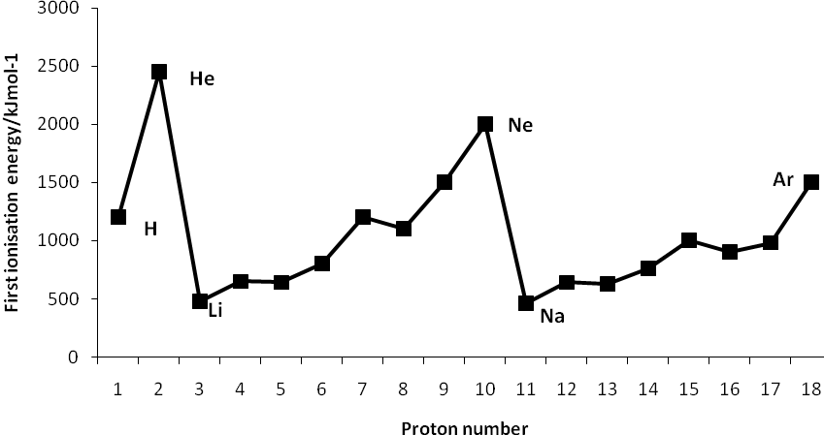
- Give the equation, including state symbols for the first ionization energy of fluorine [3]
- Explain why there is a general increase in first ionization energies from sodium to argon [3]
(c) (i) Explain why the first ionization of Aluminum is less than that of magnesium[2]
(ii) Explain why the first ionization energy of sulphur is less than that of phosphorous. [2]
The table below refers elements sodium to sulphur and is incomplete. Copy it in your answer scripts
Element | Na | Mg | Al | Si | P | S
Melting point |  | High
Conductivity |  | High
(d) (i) Complete melting point row by way of inserting Low or High only. [1]
(ii) Complete the conductivity row by way of using only high, low or moderate [1]
(d) When Mendeleev published his periodic table the elements helium, neon and argon were missing. Suggest a reason for this. [2]
(e) What effects makes the outer most electron not feel the nucleus charge well?[1]

ENVIRONMENTAL CHEMISTRY AND FUELS
9. When hydrocarbons such as paraffin wax, petrol are burned in excess of air in a laboratory. Carbon dioxide and water are the only products.
(a) Explain how NO is formed in an internal combustion engine but not formed when a small sample of petrol is burnt in an evaporating basin. [2]
(b) Write the balanced chemical equations representing burning of petrol in excess air in basin in lab. (Assume petrol is an Octane ring State symbols not vital) [2]
The engines of the cars have exhaust system fitted with catalytic convertors in order to reduce atmospheric pollution from substances such as NO.
- (i) State two other pollutants in other than CO₂ and H₂O that are present in car exhaust gases of car engines. [2]
(ii) Name one valuable (even than gold) active material found in catalytic convertors. [1]
(iii) Write one balanced chemical equation to show how NO is removed from car exhaust gases of a car engine by a catalytic convertor.(include state symbols) [2]
In a 2012 J.E.T.S fair one scientist girl senior Chemistry category noted that NO is also formed when nitrosyl chloride, NOCl dissociates according to the following equation;
2NOCl_{(g)} 2NO_{(g)} + Cl_{2(g)}
She placed the three gases in one container and closed it until the gas reached an equilibrium at 230ºC also at 465ºC.

The equilibrium data for three gases was recorded in the table below.
 | Concentration in mol/dm³
Temperature | NOCl | NO | Cl₂
230ºC | 2.33 x 10⁻³ | 1.48 x 10⁻³ | 1.15 x 10⁻²
465ºC | 3.68 x 10⁻⁴ | 7.63 x 10⁻³ | 2.14 x 10⁻⁴

- Calculate the value of K_{c} for the three gases at 230ºC and 465ºC. [4]
- Is the reaction exothermic or endothermic? Explain your answer. [2]

10 (a) Calculate the mass of lead deposited when a current of 2A is passed through molten Lead (II) bromide for 30 minutes.(Pb = 207; F = 9.65 x10⁴C/mol) [5]
(b) A constant current was passed through a copper Voltammeter and a water Voltammeter in series, for 4hours. The copper cathode was found to have increased in mass by 3.68g.
(i) Calculate the volume of oxygen measured at STP which was collected in water voltammeter. [5]
(ii) What volume of hydrogen measured at STP was collected in the same time?[5]
(Cu = 63.5, molar gas volume V_{m} at STD = 22.4dm³)

11. What is the pH of pure water at
(a) 25^{O}C (b) 50^{O}C [15]
K_{w} = 100 x 10⁻¹⁴ at 22.5^{O}C K_{w} = 5.35 x 10 ⁻¹⁴ at 50^{O}C

12. Find the pH of a buffer solution containing 0.2mols per liter CH₃COONa and 0.15 mol per liter CH₃COOH. Ka for acetic acid is 1.8 x 10⁻⁵. [15]

13. A galvanic cell is made using the Cd^{2+/}Cd and the Ag⁺/Ag redox couples. What will be the anode, the cathode and the standard cell potential? [15]
Ag⁺_{(aq)} + e⁻ Eº_{red} + 0.80V
Cd²⁺_{(aq)} +2e⁻ Cd_{(s)} Eº_{red} = -0.40V

14. Write the structural formula for each of the following organic compounds.
(a)(i) 2-MethylPropane -1,2-diol [2]
(ii) Propane-1,2,3-triol [2]
(iii) Butane-1,2,4-triol [2]
(iv) Panta -1,4-diene [2]
(v) 3-Methylbutyl ethanoate [2]
(b) Write the names of the following organic compounds.
(i)
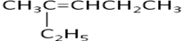 [1]

(ii) [1]
(iii) 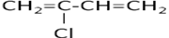 [1]
(iv) [1]
(v) C₃H₇COOC₈H₁₇ [1]

15. Oxalic acid is used in paints, cosmetics and ceramics industries and is formed in many plants and vegetables. It contains only the elements C, H, and O. If 0.513g of the acid is burned in oxygen, 0.501g of CO₂ is and 0.103g of H₂O result.
(a)(i) What is the empirical formula of Oxalic acid? If the molar mass of the acid is 90.4g/mol?
(ii) What is the molecular formula? [15]

16. Salicylic acid and acetic anhydride reacts to produce aspirin as shown below.
2C₇H₆O (s) + C₄H₆O₃(l) C₉H₈O₄ (s) + H₂O(l)
Salicylic acid acetic Aspirin
anhydride
Assume you have 14.4g of the acid and that it is the limiting reagent. Enough of acetic anhydride is present to consume the acid completely. If you obtain 6.26g of pure aspirin from the reaction. What is the percentage yield of aspirin? [15]

17. (a) The following equations involve hydrochloric acid.
Zn_{(s)} + 2HCl_{(aq)} ZnCl_{2(aq)} + H_{2(g)}
MnO_{(s)} + 4HCl_{(aq)} MnCl_{2(aq)} + 2H₂O_{(l)}+ Cl_{2(g)}
- With reference to HCl_{(aq)} state the type of reaction taking place in each case. [1,1]
(ii) State two contrasting properties of hydrogen and chlorine [2]
(b) (i) A gas jar full of chlorine gas is inverted into cold sodium hydroxide solution in a trough. State and explain the observations made. [2]
(ii) Chlorine gas reacts with hydrogen gas. Write an equation for the reaction and state the conditions under which this reaction can occur safely. [2]
(iii) Chlorine is used as a bleaching agent for many articles.
- State articles bleached by chlorine and those that are not beached [2]
- Articles bleached by chlorine are always thoroughly washed in water after bleaching. Explain [2]
(iv) Chlorine is also used in manufacturing of bleaching powder CaOCl₂ .H₂O.
Write an equation to show bleaching powder is formed. [2]
(v) Bleaching powder when exposed to air detoriates and smells of chlorine. Explain [2]

18.

MARKING GUIDE
- R = K [X]ª[Y]^{b}
0.02 = K[0.01]ª[0.04]^{b} [1]
0.08 = K[0.02]ª[0.04]^{b}

Log0.02 = log K + alog0.01 + blog0.04 [1]
Log0.08 = log K + alog0.02 + blog0.04

-0.602869874 = -0.30102996a [1]
-0.301029969 -0.30102996

2.00 = a [1]

0.08 = K[0.04]²[0.02]^{b} [1]
0.12 = K[0.04]²[0.03]^{b}

Log 0.08 = log K + log 0.04²+ blog0.02 [1]
Log 0.12 = log K + log 0.04²+ blog0.03

Log 0.08 =blog0.02 [1]
Log0.12 = blog0.03

-0.17609125 = -0.1760912596b [1]
-0.17609125 -0.1760912596

1.0 = b

0.02 = K[0.01]²[0.04]¹ [1]

0.02 = K[0.0001][0.04]

0.02 = 0.000004K [1]
0.000004 0.000004

5000 = K [1]

Overall order of reaction = 2+1 = 3 [3]

- (a) – log [1.0 x 10⁻⁴] = pH [1]
pH = 4 soda [1]

(b) pK_{a} = pH + pOH [1]
14 = pH + -7.602 [1]
pH = 6.3979 ≈ 6.4 Milk [1]

- pOH = -log [1.0 x 10⁻¹³] [1]
pOH = 13
14 = pH + 13
pH = 14 -13
pH = 1 Stomach acid [1]

- 14 = pOH +pH pH = pOH [1]
14 = 2pH
pH = 7 [1]
-log [H] = 10⁻⁷ [H] = 0.0000007M [1]

- (i) a buffer solution [1]
(ii) It does not change the value of the soil. [1]
- (i) ARRHENIUS BASE [1]
(ii) ARRHENIUS BASE [1]
(iii) LEWIS ACID [1]

- (a) Isomers [1]
(b)(i) Oxygen violets valency bonding rules [1]
Carbon on your right also violets bonding rules [1]
(ii)

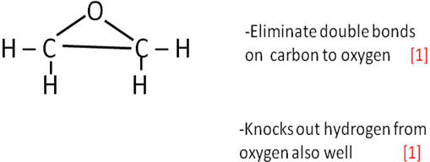
(c)(i) Cyclohexane Hexene (Any two ) [2]
-It is a saturated H.C -unsaturated
-has single bonds between carbons -has double bonds
-does not decolourise bromine solution -decolourise bromine
-it is a ring - straight chains
(ii) C_{n}H_{2n} [1]
(iii) -Same general formula (C_{n}H_{2n}) [3]
-they are hydrocarbons
-same amount of carbon and hydrogen
(d)(i) the added lead metal [1]
(ii) replacing leaded petrol with un leaded petrol [1]

- (a) ΔH _{rxn} = ΔH_{prod} - ΔH_{rxtant}
ΔH _{rxn} = -1367 - -1411 [1]
ΔH _{rxn} = + 44Kj/mol [1]
(b) (i) T
(ii) because they are pratical ones.
(iii) C₂H₅OH _{(l)} + O₂ _{(g)} CO_{2(g)} + H₂O_{(l)} [1] eqn [1] sym
(c) (I)
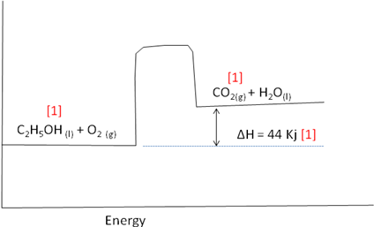
(ii) Endothermic reaction [1]

- (a)(i) electrons [1]
(ii) the nucleus charge on protons/attraction by nucleus. [1]
(iii) the orbitals/shells [1]
(b)(i)
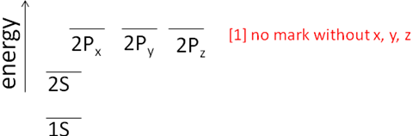 [1] general presentatn
(ii)
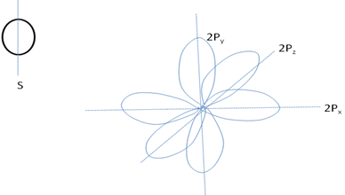 [1, 1]
(iii)
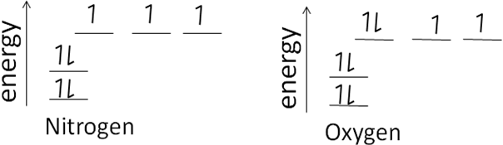[2,2]
(iv) N³⁻ O²⁻ [1,1]
(v) it is easier to gain 3 and 2 electrons than to lose 3 and 4 electrons respectively for nitrogen and oxygen [1, 1]

- (a) formula mass for C₇H₁₄O₂ = 130g/mol
n(formula mass) = molecular mass
n(130) = 130 [1]
130 130
n = 1 [1]
(b)(i) C₅H₁₂O C₂H₄O₂
88g 60g OR 88 60
860Kg x x 860

X = 60 x 860 x = 1261.3kg
88
X = 586.4Kg [2 ]for working]
- Acetic acid is in excess reagent [1]
- Ethanol is limiting reagent [1]
[2] can be awarded if one used moles to calculating excess or limiting.
(iii) C₅H₁₂O C₇H₁₄O₂
88g 130g
860kg x
X = 130 x 860
88
X = 1257.5Kg [1]

%yield = Actual yield x100% [1]
Theoretical
%yield = 1020 x 100% [1]
1270.5
%yield = 80.3% [1]
(c) Excess reagent remained = 860 – 586.4 = 273.6Kg [3]
(d)(i) Esters [1]
(ii)
[2]
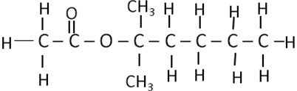

- (a) Bauxite or Cryolite any of the two [1]
(b)(i) Molten Aluminum oxide is placed in electrolytic cell
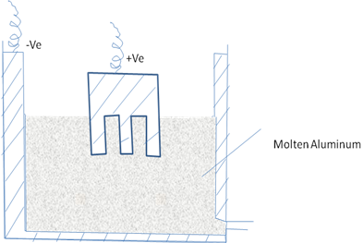 [2]
Electrodes Anode Graphite
Cathode Graphite [1, 1]
(c)(i) it is light
Does not rust
It soft to be precisely be mode in the right. Any two [2]
- (i) Any one
Fe + HCl FeCl₂ + H₂
Fe ²⁺ Fe³⁺ [2]
(ii) Oxidation [2]
(iii) Iron(II) is green colour then Iron(III) is brown in colour solution [1]

8 (a) F _{(g)} F⁻_{(g)} + e⁻ /F_{(g)} + e⁻ F⁻_{(g)} [3]
(b) This is because of increase number of protons which offer effective shielding or screening effects and the atomic radii of atoms decreases hence requiring more energy. [3
(c)(i) Magnesium atom has a larger atomic radius than aluminum; hence effective electron shielding is strong in aluminum than magnesium. [2]
(ii) Sulphur has a smaller atomic radii than phosphorous hence effective shielding is felt more by sulphur than phosphorous. [2]
(d)(i), (ii)
Element | Na | Mg | Al | Si | P | S
Melting point | Low | ------------ | high | high | low | Low
Conductivity | high | ------------ | High | moderate | low | low
[1, 1]
(e) They had not been discovered yet [2]
(f) shielding or screening effect [1]

9. (a) by burning of nitrogen in a enclosed cylinder [2]
(b)(i) 2C₈H₁₈ +25 O₂ 16CO₂ + 18H₂O [2]
(c)(i) Lead oxide PbO
Nitrogen monoxide NO [1, 1]
(ii) Platinum [1]
- N₂ + O₂ 2NO [2]
(d) at 230^{O}C K_{c} = NO²[Cl] =
[NOCl]²

10. (a) Electrode reaction is Pb²⁺ + 2e⁻ Pb [1]
One mole of lead is produced by 2 moles of electrons.

Q = It = 2x30x60C
n = It/ZF n =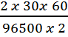 [2]
mass of Lead = 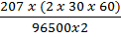 = 3.86g [2]

(b)(i) Cathode increase in mass by 3.86g
3.86/63.5 mol = 0.58 mol [2]
Cu²⁺ + 2e⁻ Cu
1 mol Cu = 2 moles of electrons.
0.058 x 2 moles = 0.106 moles of electrons.
4OH⁻ 2H₂O + O₂ + 4e⁻
1 mol O₂ 4 moles of electrons
0.106 mol = 0.106/4 mol O₂ gas = 0.0265mol [3]
(ii) 1 mol gas at STP =22.4dm³
0.0265 mol = 0.0265 x 22.4 = 0.594dm³ = 594cm³ [3]
At the cathode, 2H⁺ + 2e⁻ H_{2(g)}
1mol H₂ == 2 moles of electrons twice the volume of hydrogen is liberated
therefore = 2x 0.594dm³ = 1.19dm³ = 1190cm³

11 (a) K_{w} = [H⁺][OH⁻] = 1.00 x 10⁻¹⁴ [1]
[H⁺] = [OH⁻] [1]
Let y = [H⁺] = [OH⁻] [1]
y² = K_{w} [1]
y² = 1.00 x 10⁻¹⁴ [1]
y = = 1.00 x 10⁻⁷ [1]
pH = - log y = log 1.00 x 10⁻⁷ [1]
pH = 7.00 [1]
(b) at 50^{O}C
K_{w} = 5.35 x 10 ⁻¹⁴ [¹/₂]
K_{w} = [H⁺] = [OH⁻] [¹/₂]
y = [H⁺] = [OH⁻] [¹/₂]
K_{w} = y x y [¹/₂]
= y² [1]
y = 2.31 x 10 ⁻⁷ [H⁺] = [OH⁻] [1]
pH = -log [H⁺] [1]
=-log 2.31 x 10⁻⁷ [1]
pH = 6.64 [1]

12. K_{a} = 1.8 x 10⁻⁵ [1]
pK_{a} = - log (1.8 x 10⁵) = 4.7447 [1]
then use Henderson-Hasse/balch eqn pH = pK_{a} + log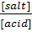 [2]
= 4.7447 + log [0.02]/0.15 [2]
= 4.7447 + log 4/3 [2]
= 4.7447 + 0.6021-0.4771 [2]
= 4.8697 [2]

13. Anode (oxidation) [1]
Ag/Ag⁺ Ag _{(s)} Ag⁺_{(aq)} + e⁻ Eº_{red} + 0.80V [2]
Cathode (Reduction) [2]
Cd²⁺/Cd Cd²⁺_{(aq)} +2e⁻ Cd_{(s)} Eº_{red} = -0.40V [2]
Ag/Ag⁺//Cd²⁺/Cd Eº_{Cell} = Eº_{Cathode} - Eº_{anode} [2]
2Ag_{(s)} + Cd²⁺_{(aq)} 2Ag⁺ _{(aq)} + Cd_{(s)} [2]
Eº_{cell} = Eº_{cathode} - Eº_{anode} [1]
= -0.40V -0.80V [2]
= -1.20V

14. (a) (i)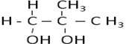 [2]
(ii) 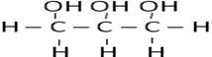 [2]
(iii) CH₂OHCHOHCH₂CH₂OH [2]
- CH₂=CH – CH₂-CH=CH₂ [2]
- CH₃COOCH₂CH(CH₃)₂ [2]
(b) (i) 3-Ethyl-5-methylhex-2-ene [1]
(ii) Hexa-1,4-diene [1]
(iii) 2-Chlro-1,3-butadiene [1]
(iV) Buta – 1-ene – 3yne [1]
(v) Octyl Butanoate [1]
15. Moles for C and H
Mol = 0.501g/44.01 = .0114 mol CO₂ [1¹/₂]
Mol = 0.103g/18.02 = 0.0072 mol H₂O [1¹/₂]
- Mass of C and H in CO₂ and H₂O
Mass = mol x MM = 0.0114ml x 12 = 0.137g Carbon [1¹/₂]
Mass = mol x MM = 0.00572 mol x 2g = 0.0115g Hydrogen [1¹/₂]
0.513g sample of oxalic acid contains 0.137g C, 0.0115g H, and 0.365g of Oxyen.
- Empirical formula
Ratios of each item in sample.
C : H : O
0.137/12 :0.0115/1.0041 :0.365/16 [1]
0.0114 : 0.0114 :0.0228
0.0114/0.0114 : 0.0114/0.0114 : 0.365/0.0114 [1]
1 : 1 : 2 CHO₂ [1]
- Molecular formula
Molecular formula = n(empirical formula)
n = (90.04/45.02) = 2 [1]
Molecular formula = (CHO₂)2 [1]
C₂H₂O₄ for Oxalic acid [1]

17. Step one: moles of a limiting reagent.
Moles = 14.4/138.1g = 0.10mol of salicylic acid [3]
Step two: moles of Aspirin produced.
Molar ratio Salicylic acid : Aspirin
2 : 2
0.104 x [2]
2x = 0.104 x 2 [1]
X = 0.14 moles Aspirin [2]
Step three: Mass of aspirin produced.
Mass = moles x MM 0.104 moles x 180.2 = 18.8g aspirin [2]
Step four: % yield
% yield = actual yield/theoretical x 100%= 6.26/18.8 x 100 = 33.% [2,2,3]

17. (a)(i) Reaction I displacement
Reaction II oxidation
- Hydrogen Chlorine
- Reducing agent Oxidizing agent
- Does not bleach Bleaching gent
B(i) Sodium hydroxide rises in the gas jar. Chlorine reacts with absorbed by sodium hydroxide forming a mixture of Sodium hypochlorite and Sodium chloride
(ii) Cl₂(g) + H₂(g) 2HCl(g)
Expose mixture in diffused light or burn a jets of hydrogen in chlorine gas.
- I Cotton, linen and wood pulp not used for silk and wool
II To wash away hydrochloric acid which is always produced when chlorine bleaches as shown below.
HOCl_{(aq)} + Cl_{2(g)} (Dye –O) + HCl_{(g)}
- Ca(OH)_{2(s)} + Cl_{2(g)} CaOCl₂.H₂O
- Atmospheric Carbon(II)oxide in moist air forms carbonic acid which acts on bleaching powder producing chlorine gas
CaOCl_{2(s)} + H₂CO_{3(aq)} CaCO_{3(s)} + H₂O_{(l)} +Cl_{2(g)}

